**E-Commerce Shopping Store**

POC

**Low Level Design (LLD)**

**Index**

Overview 3

Use Cases 5

**Tables** 6

**Categories Table** 6

**Customers Table** 6

**Categories Table** 7

**Order Details Table** 7

**Order Table** 8

**Products Table** 8

**ShoppingCart Table** 9

**Relationship Diagram** 10

Class Diagram 11

Control Flow 12

**Manager – Create Task – Flow** 13

**Overview**

This document contains the detailed design information about **Ecommerce Shopping Store** application.

The application has 2 types of users:

* Admin
* Customers/User

• User can view and purchase products.

• An Admin has some extra privilege including all privilege of user.

* Admin can add products, edit product information and add/remove product.
* Admin can add user, edit user information and can remove user.
* Admin can ship order to user based on order placed by sending

confirmation mail.

**ONLINE SHOPPING APPLICATION:**

Anyone can view Online Shopping portal and available products, but every user must login by his/her Username and password in order to purchase or order products. Unregistered members can register by navigating to registration page. Only Admin will have access to modify roles, by default developer can only be an ‘Admin’. Once user register site, his default role will be ‘User’.

This Online shopping Application should provide the following features to the customers:

1. Customer Registration

2. View Product Details

3. Purchase Products

4. Confirm the Order

Note: Other that First Time registration, the other operations are allowed only for registered customers.

Once the Order is confirmed, Cyber shopee will deliver the ordered products to the customer on his address specified during the registration. The Payment mode will be Cash On Delivery.

**Use Cases**

There are 2 types of Actors in the System: Customer and Admin.

**Table Structure**

**Categories Table**

Categories: This will contain various Categories for the Products available.

The column descriptions are given below:

|  |  |
| --- | --- |
| **Column** | **Description** |
| CategoryId | Primary Key, FK, int, not null |
| CategoryName | Name of the Category of product, varchar, not null |
| Description | More information about the product category, varchar. |

**Customer Table**

* 1. Customers: This will contain the list of Customers.

The column descriptions are given below:

|  |  |
| --- | --- |
| **Column** | **Description** |
| CustomerId | Primary Key, FK, int, not null |
| fullName | Name of the Customer, varchar |
| Email Address | Email id of customer, Varchar, |
| Password | Password set by the customer |
| Delivery Address | Product delivery address of customer. |

**Order Details Table**

Order Details: This will contain the details of the Products Ordered.

The column descriptions are given below:

|  |  |
| --- | --- |
| **Column** | **Description** |
| OrderId | FK, int, Id of the order |
| ProductId | ProductId , FK, int |
| Quantity | Quantity of the product, Primary Key, int |
| UnitCost | Cost of the product |

**Order Table**

Orders: This will contain the Master details of Orders.

The column descriptions are given below:

|  |  |
| --- | --- |
| **Column** | **Description** |
| OrderId | Primary Key, int |
| CustomerId | CustomerId,FK, int |
| Order Date | Date on which the product is ordered |
| ShipDate | Shipping date of the product |

**Product Table**

Products: This contains the list of products available in the shopping store for purchase.

The column descriptions are given below:

|  |  |
| --- | --- |
| **Column** | **Description** |
| ProductId | ID of the Product, Primary Key, FK, int, not null |
| CategoryId | CategoryId, FK, int, not null |
| ModelNumber | Model Number of the product, Varchar, |
| ModelName | Model Name of the product, varchar |
| UnitCost | Cost of the product. |
| Description | Product placed for order by customer. |

**ShoppingCart Table**

Shopping Cart: This table will store the details about the Cart.

The column descriptions are given below:

|  |  |
| --- | --- |
| **Column** | **Description** |
| RecordId | Primary Key, FK,int |
| CartId | cartId, int |
| Quantity | Quantity of the product,FK |
| ProductId | ProductId, FK,int |
| Date Created | Date on which the cart is created. |

**Relationship Diagram**

Following is the relationship diagram for the above tables.

**Class Diagram**

**Control Flow**

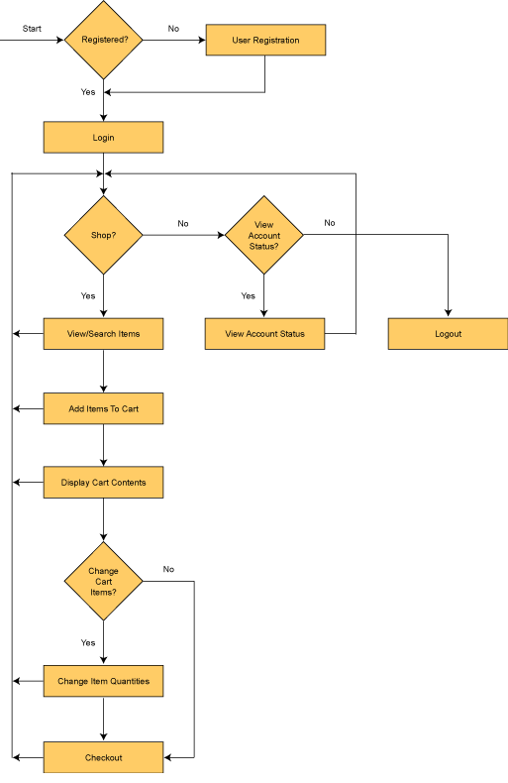

* **Login / Sign In**: Login screen would display asking user to enter ‘User Id’ & ‘Passwd’. If the supplied user credentials are valid the HomePage would be displayed, else appropriate Login error message would be displayed.
* **First time users Register**: First time new users would use this screen to create their profile (userId and password). On click of ‘Submit’ button new user entry (user id & password) would be saved into database table for further user authentication purpose.
* **Home Page**: On successful user authentication (validation of userid/password provided by the user in login screen) the homepage would be displayed. The Homepage would contain below sections/contents:

Header section: The header section would be common across all the pages and

would mainly have –

Sign In – On click it would take to Login page

Account – On click it would take to Account History page which displays all the shopping carts details by the logged in user.

Cart – On click it would take to Shopping Cart screen which displays the cart details of the current active Shopping Cart.

* **Category View and select product**: This screen allows the customers to see all the categories and select the category to purchase the product from that category. Depending upon the selection, it should go to Product Details screen displaying the details about the products in that category.
* **Product Detail:** This screen allows the Customers to see the products from the selected category. It should provide the option to Add select product to Cart.
* **Shopping Cart:** It would display all the products added to cart, below fields are to be displayed for each added product.

• Product Id

• Product Name

• Model

• Quantity – User can change the quantity of any product

• Price

• Sub-total (Price * Quantity)

• Total Amount

Remove option for removing any of the products from the shopping cart.

**Update Shopping cart** – This link to be provided for updating the shopping cart (sub-total amount, selected items to be removed). On click of this link the page would be refreshed with the updated subtotal amount (i.e. Quantity * Price)

**Final Check Out** – This link would be used by the user to do the final check out (for confirmation and submission of the order).